HomeShare 2.0 – B.Tech Major Project Report (Draft)
Verified Community Food Marketplace

Abstract
HomeShare is a verified community food marketplace connecting customers, home cooks, delivery walkers and administrators. The platform introduces KYC verification, trust scoring, AI recommendations and community engagement.HomeShare is a verified community food marketplace connecting customers, home cooks, delivery walkers and administrators. The platform introduces KYC verification, trust scoring, AI recommendations and community engagement.HomeShare is a verified community food marketplace connecting customers, home cooks, delivery walkers and administrators. The platform introduces KYC verification, trust scoring, AI recommendations and community engagement.

Introduction
The project aims to solve the lack of trust and discoverability in homemade food markets by providing a verified ecosystem.The project aims to solve the lack of trust and discoverability in homemade food markets by providing a verified ecosystem.The project aims to solve the lack of trust and discoverability in homemade food markets by providing a verified ecosystem.

Problem Statement
Home cooks lack access to digital markets while customers struggle to identify trustworthy homemade food providers.Home cooks lack access to digital markets while customers struggle to identify trustworthy homemade food providers.Home cooks lack access to digital markets while customers struggle to identify trustworthy homemade food providers.

Objectives
Create a secure marketplace, implement seller and walker KYC, provide delivery management, trust scores, AI recommendations and subscription plans.Create a secure marketplace, implement seller and walker KYC, provide delivery management, trust scores, AI recommendations and subscription plans.Create a secure marketplace, implement seller and walker KYC, provide delivery management, trust scores, AI recommendations and subscription plans.

Modules
Customer, Seller, Walker, Admin, KYC, Payment, Analytics and Recommendation modules.Customer, Seller, Walker, Admin, KYC, Payment, Analytics and Recommendation modules.Customer, Seller, Walker, Admin, KYC, Payment, Analytics and Recommendation modules.

Seller KYC
Identity verification, address verification, kitchen verification and bank verification.Identity verification, address verification, kitchen verification and bank verification.Identity verification, address verification, kitchen verification and bank verification.

Walker KYC
Identity verification, vehicle verification, driving license verification and payment account verification.Identity verification, vehicle verification, driving license verification and payment account verification.Identity verification, vehicle verification, driving license verification and payment account verification.

Trust Score
Identity 20%, Kitchen 25%, Reviews 30%, Order Success 15%, Complaint Ratio 10%.Identity 20%, Kitchen 25%, Reviews 30%, Order Success 15%, Complaint Ratio 10%.Identity 20%, Kitchen 25%, Reviews 30%, Order Success 15%, Complaint Ratio 10%.

Revenue Model
Order commission, premium subscriptions, sponsored listings, delivery charges and corporate meal contracts.Order commission, premium subscriptions, sponsored listings, delivery charges and corporate meal contracts.Order commission, premium subscriptions, sponsored listings, delivery charges and corporate meal contracts.

Future Scope
AI nutrition assistant, blockchain traceability, GPS tracking and IoT kitchen certification.AI nutrition assistant, blockchain traceability, GPS tracking and IoT kitchen certification.AI nutrition assistant, blockchain traceability, GPS tracking and IoT kitchen certification.

Entity Relationship Diagram
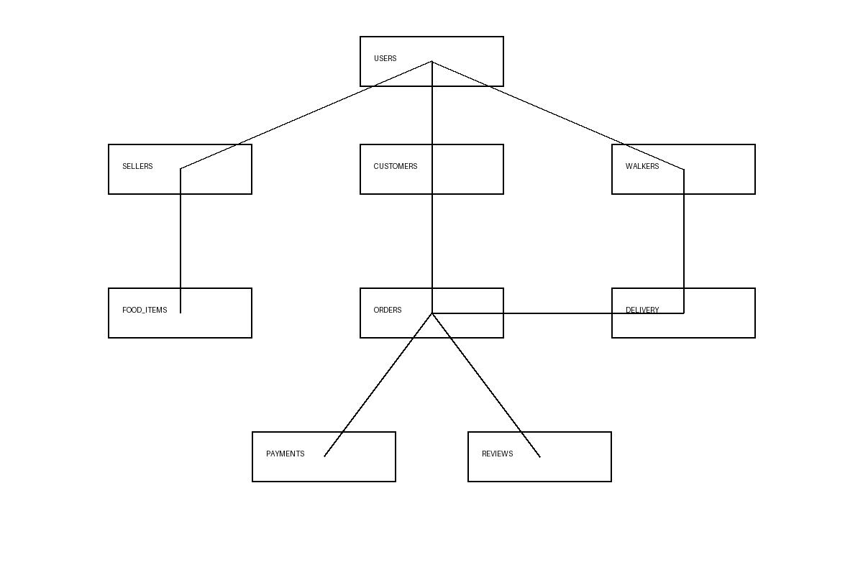
The ER diagram illustrates relationships between users, sellers, customers, walkers, food items, orders, deliveries, payments and reviews.

